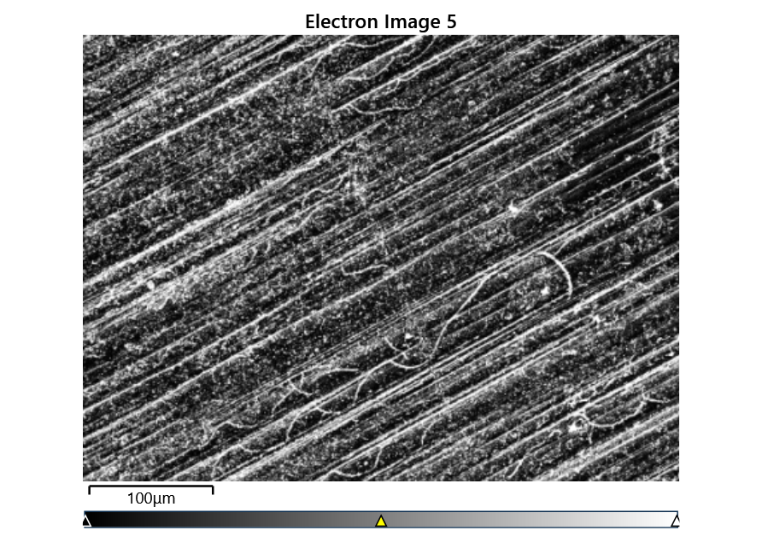



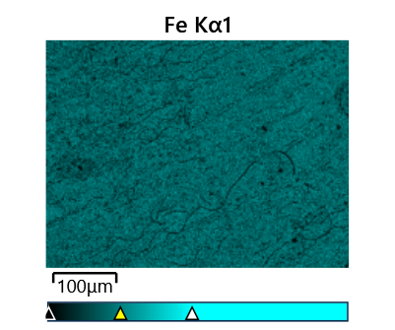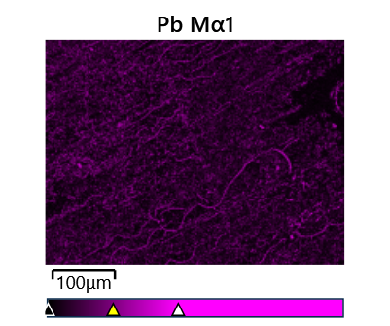

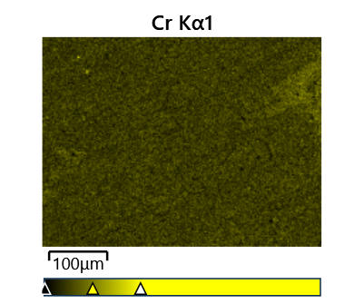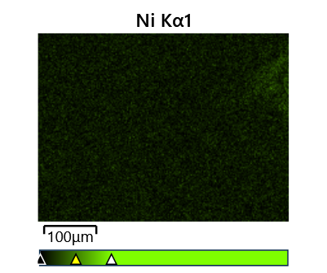

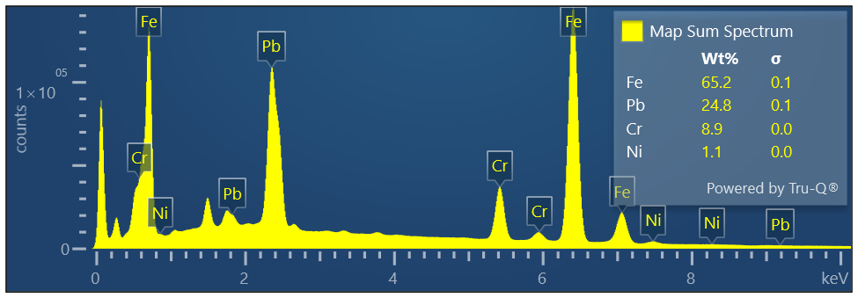

Map Sum Spectrum

Element Signal Weight % σ

Fe 65.16 0.06

Pb 24.80 0.05

Cr 8.93 0.03

Ni 1.10 0.03

**Map Sum Spectrum**

**Element Signal Atomic % σ**

**Fe 78.99**

**Cr 11.63**

**Pb 8.10**

**Ni 1.27**